EXPENSES TRACKER

ABSTRACT
Expense Tracker is a simple C++ programming project used to maintain daily expense records digitally. The system allows users to add expenses, view expenses, calculate total expenses, add income, and calculate savings. The project helps users manage financial records efficiently and reduces manual calculations.

INTRODUCTION
Expense Tracker is developed using C++ programming language to help users manage their daily expenses effectively. In traditional methods, maintaining expense records manually is difficult and time-consuming. This project provides an easy way to store expense details digitally and calculate total spending and savings automatically.

ALGORITHM
1. Start the program
2. Display menu options
3. Read user choice
4. Add expense details
5. View expenses
6. Calculate total expenses
7. Add income details
8. Calculate savings
9. Repeat until user exits
10. Stop the program

FLOWCHART
START
↓
Display Menu
↓
Enter Choice
↓
Add/View Expenses
↓
Add Income
↓
Calculate Savings
↓
EXIT
↓
STOP

METHODOLOGY
The project is developed using C++ programming language. File handling concepts are used to store expense and income records. Different functions are used for adding expenses, viewing expenses, calculating total expenses, adding income, and calculating savings. The menu-driven approach makes the system easy to use and understand.

RESULT

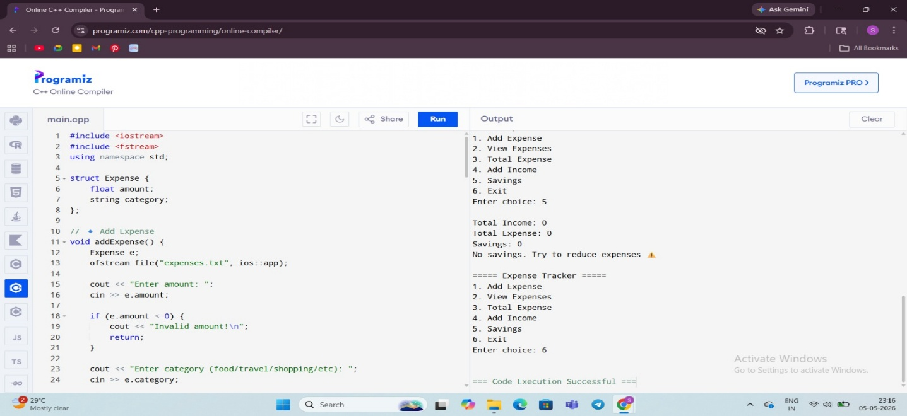

CONCLUSION

The Expense Tracker project successfully manages expense and income records efficiently. It demonstrates the practical implementation of C++ programming concepts and file handling in real-life applications.

FUTURE WORK
In future, this project can be improved by adding database connectivity, monthly reports, graphical user interface, and mobile application support.

